**Threadlinkers Quick Start Guide**

A digitally assisted Tabletop RPG

**Table of Contents**

About this Guide 1

Introduction 1

Personality Colors 1

Where Magic Comes from 3 Installing Threadlinkers Assistant 3

Navigating the Utility 4

Character Statistics 7

Character Creation 8

Character Actions 9

Saves and other reactions to attack / danger 10

Wisdom Saves 12

Other Changes from 5th Edition 12

**About This Guide**

This guide is a quick introduction to the Threadlinkers RPG system for those who are familiar with other RPG systems. This guide will not go into detail on the conventions of how tabletop role playing games generally work, but will instead focus on the peculiarities of Threadlinkers. Those who have played Dungeons and Dragons 5th edition will feel especially at home, though the author is keen to point out that Threadlinkers is unique in many critical ways which makes gameplay significantly different from 5th edition.

**Introduction**

Threadlinkers is a system that focuses almost exclusively on magic. There are no character classes, separated spell lists, or even hard levels, only spells, some simple stats, and one’s unique personality and philosophy. If you desire hard curated structure to character progression or if you dislike magic in general, then Threadlinkers is not for you. Otherwise, welcome everyone else, let this author take you for a trip.

Spells in Threadlinkers are organized according to level, much like in Dungeons and Dragons. You have spell slots and cantrips and all that good stuff. Where Threadlinkers differs is in how you learn spells, as previously mentioned there are no hard levels or spell lists, so how does it work?

Well, in Threadlinkers you earn Spell Points, which function much like the skill points found in many video games. Spending a certain amount of spell points will allow you to learn a spell, simple enough. However, there are certain things that can change how expensive a spell is to learn. Two things. One, knowing spells related to the spell in question will make it easier to learn, as you have previous experience. And Two, your personality aspects (colors as we will call them later) will make learning certain types of spells easier or harder.

**Personality Colors**

There are six personality aspects in Threadlinkers and you select two that you feel represent your character during character creation. These aspects are quite broad, and can have multiple interpretations depending on the type of character you are trying to create, so you’ll have little trouble applying them to any character with some thought.

The six personality aspects are as follows: White, Black, Blue, Green, Red, and Brown, and they are loosely based upon the color pie from the Magic The Gathering Card Game. More extensive descriptions are as follows:

White: External Moral structure and hierarchy, association with the law, virtuous, values order, typically values the community, “Good things should happen to good people.”

Black: Consequentialism, avoidance of external moral structure save for one's own, typically dislikes authority, changes the world according to their own design, "Whatever it takes, even if..."

Blue: values knowledge, learning, curious, inclined to be dissatisfied, like to make things bend, experimental. “What? Where? Who? When will you answer my questions?”

Green: Natural, values heritage, tradition, & alleged destiny, values “natural” growth, darwinism (social or otherwise). “Who are you to deny what is natural?”

Red: impulsive, emotional, passionate, creative/destructive, rage/chaos, action-based. “Live brightly”

Brown: Stoic, unmoved by troubles, patient, stable, calm/determined. “Stand where you stand”

The typical spell association of the different colors are as follows:

White: Light magic, best healing, second-best buffs (to others), robust charming magic

Black: Typically quite neutral. Greater ease for dark magic, illusions, and Necromancy, very poor charming magic

Blue: Best Divination magic and unique spells with odd effects, spells that tinker with situations. Best Transmutation.

Green: Nature magic augmented with some defensive buffs, second best healing

Red: Lots of powerful Evocation magic, detriment to defensive magic and buffs, better than average charming magic. Aggressive mobility magic.

Brown: Elemental Earth magic, best defensive and buff magic, detriment to charming magic

**Where Magic Comes From**

In the universe Threadlinkers is set in, magic is derived from personality. This power typically lays dormant in most creatures, but can sometimes be activated by significant events in a creature's life. In the following sections where you are using Threadlinkers Assistant to have your character learn spells, think about the story behind each spell, and why that spell would manifest over others. From your character's perspective, what magic they learn is largely beyond their control, it comes from who they are.

Additionally, as a fun side effect of magic being derived from personality, all magical items in the world have a personality, even if they aren’t completely sentient and aware.

**Installing Threadlinkers Assistant**

Threadlinkers Assistant is the companion program to this guide. It can help you manage your character by automatically doing all the calculations for how much spells cost, and presenting it in a user-friendly interface where all important information is present. It allows you to browse spells by level and has color-coded tags for which spells are most fitting for a given type of personally color.

Installing Threadlinkers Assistant is easy on any Windows machine you might have (provided it has at least Windows 2000 installed). Simply place the “001-Programs” folder provided to you into your “C:” drive and you’re ready to go!

If for some reason you need to check the integrity of the utility files, inside the programs folder there should be a folder called “Threadlinkers Assistant”. This is where the program lives. Inside this folder should be the utility executable and two other folders, named “Characters” and “Spells”. Inside the characters folder you will find the character files for any characters you might have made. The spells folder should contain 10 other folders. One for each level of spells, including cantrips. You should be able to find the file for any spell this way.

**Navigating the Utility**

Upon opening the program executable, you should be greeted by a screen that should look like this:

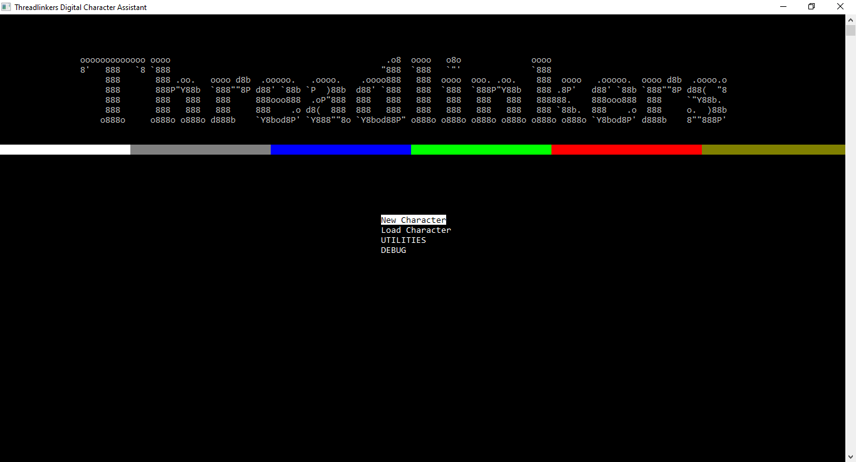

There should be two main options: New Character, and Load Character. You can navigate this menu using the WASD keys and ENTER. Selecting the New Character option will allow you to enter information to create a new character file. It's not an in-depth creator that gives you full context though, so keep reading.

Selecting the Load Character option and selecting a character from the list that pops up (or completing the creation of a new character) will bring you to a screen that looks like this:

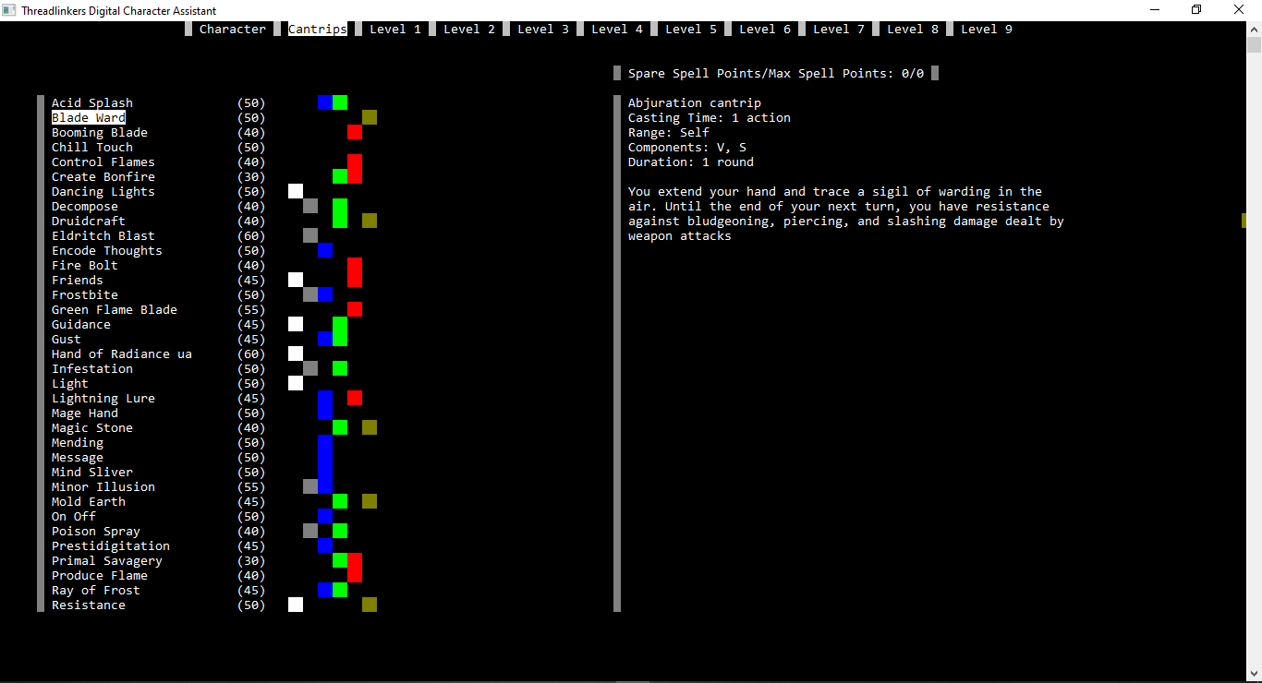

Do not panic, this is the spell menu. On the top edge you can see the different levels of spells as well as an option called “Character”, more on that later. One of the options is highlighted, which indicates which part of the menu you are in. In the above picture Cantrips are being shown. Hitting A or D will cause the menu to shift left or right one option.

Hitting W or S will allow you to scroll though the list of spells for a given level. The list auto-scrolls when you reach either end. To the immediate right of the names of the spells are numbers in parenthesis. These are very important, these are the costs for the different spells at the current moment. Recall that spell costs can change depending on one's colors and other known spells.

To the right of the costs you can’t help but notice an assortment of colored squares. They are organized into columns according to color, and each row corresponds to a spell. If a spell has a color associated with it, then that spell is connected positively to the color.

On the right half of the screen are two important pieces of information. One, there is the description of the currently selected spell. If the spell’s description extends beyond the single page, hitting 1, 2, or 3 on your keyboard will display the corresponding page. Above the description is a readout of the number of spare spell points that are available to use to learn spells, as well as the total number of spell points you have.

Hitting enter with a spell selected will prompt the program to ask you for confirmation on if you want to learn that spell, using the “y” or “n” key. If you choose to do so, your spare spell points will drop accordingly and your character file will be automatically updated and saved.

Moving to the “character” section of the menu will display a character's critical information. It should look something like this:

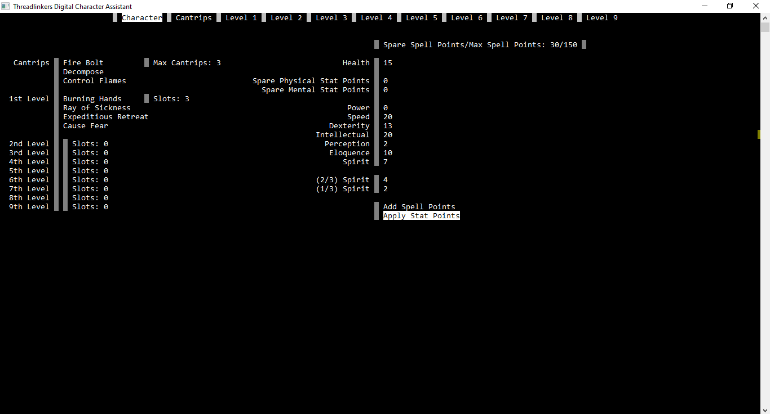

On the left you will see your characters spells as well as their spell slots. On the right you will see your characters stats as well as a little menu with two options. Selecting “Add Spell Points” will pop up a prompt asking how many you would like to add, type in a number and hit enter. If you selected it by accident, then just enter 0 as the amount.

Applying Stat points is a little more complex. By selecting this option a selector menu will appear. It should look something like this:

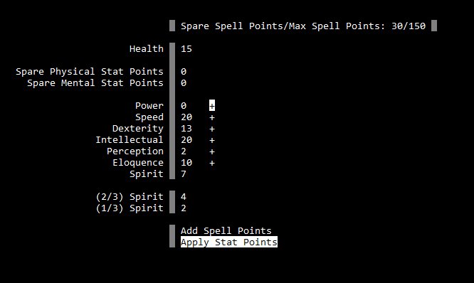

You can back out of this menu by hitting SHIFT. Hitting W or S will allow you to change what stat you’re targeting. Hitting Enter will display a prompt much like the one that showed up for the Spell points. Enter a numerical amount, 0 if you made a mistake.

**Character Statistics**

There are 7 character statistics in Threadlinkers: Power, Speed, Dexterity, Intellectual, Perception, Eloquence,.and Spirit. These stats can range from 0 to 100. The usages of the different stats are as follows:

**Power:** Represents physical might and endurance. Used when determining the damage of physical blows as well as enduring certain spell effects, such as weathering the blast from a fireball without attempting to move out of it’s area of effect. Certain heavier types of armor might require greater Power to wear properly.

**Speed:** Represents how quickly one can move. Used to determine movement speed and jumping distance. Additionally, provided the armor you are wearing permits it, it can also be applied to dodge saves for both melee hits and area effects (by moving out of the area of effect using a reaction)

**Dexterity:** Represents physical precision. Used to determine if melee attacks made by your character hit or not, useful for parry saves. Additionally, it’s used for sneak checks as well as many tool checks.

**Intellectual:** Represents one’s skill in academic matters. History, religion, alchemy, medicine, library use, and the deciphering of tomes are covered under this skill.

**Perception:** Represents one’s skill in detecting subtle details about one’s environment and the people in it.

**Eloquence:** Represents one’s ability to clearly organise their ideas and communicate them to others. This comes into play often when interacting with NPC’s. Additionally, a higher eloquence stat allows one to speak longer during combat.

**Spirit:**.The universal spellcasting ability stat. This stat is unique in that it cannot be raised manually like the others. Instead, it naturally increases over time as one accumulates spell points.

**Character Creation**

Character creation in Threadlinkers is a relatively simple process. Many superfluous features present in other systems have been omitted for clarity and simplicity’s sake. When creating a character in Threadlinkers you should think carefully about your character's history and the reasons behind why they see the world they do. Try to think about major life events that could inspire spell choice. Characters in Threadlinkers are created with two characteristic spells and two characteristic cantrips, all four of which are free. On top of that, as most GM’s will start characters with about 100 total spell points (which is roughly equivalent to a level 1 character) so you’ll have roughly 2-3 Cantrips and 2 - 4 spells to start out with.

**Characteristic Spells and Cantrips**

Characteristic Spells and Cantrips can technically be any 2 1st Level spells and 2 Cantrips, but it is highly encouraged and recommended that players choose spells that correspond to their colors (for these initial spells) and only go against that for very clear and core character reasons. These are your characters first manifestations of power that represent the core of their personality, ideology, and who they are. They are relevant to your character's background and past, ideally being directly linked to major events. Make them count.

**Races**

A selection of a race in Threadlinkers typically does not grant special features. In cases where this would conflict with characterization players should consult their GM.

**Skills, Tools, and Languages**

**Character actions**

Whenever you have your character do a potentially difficult task your Game Master will typically ask for an ability roll. The typical format for an ability roll is to roll a d100 and add the relevant stat specified by your Game Master. If your roll is higher than the DC (difficulty class) specified by your GM (your GM doesn’t have to verbally specify the DC, but they must have it in mind before you make the roll) then you succeed, otherwise you fail. The degree to which you succeed or fail is typically determined by the margin by which you pass or fail the dice roll.

**Casting a spell**

When you cast a spell you must expend a slot of appropriate level if it is not a Cantrip. Casting mechanics regarding spell levels and slots are the same as in 5th Edition D&D.

**Making an attack**

Making a melee attack is a little different than in 5th Edition. As in 5th Edition there is an attack roll and a damage roll. The attack roll determines if the attack hits or not, and the damage roll determines the damage.

For a non-magical attack, such as using a sword, bow, or rifle, you roll a d100 and add your Dexterity score. For a magical attack, you add your Spirit score instead of Dexterity.

Magical attacks typically don’t have modifiers to their damage rolls, but melee attacks do. When determining the damage from a melee attack, for every 5 points of Power that you have, you deal +1 damage.

For example, if you had a power score of 28, you would deal +5 damage on hits. You would have to raise your power score to 30 if you wanted to deal +6 damage.

**Saves and other responses to attack or danger**

On your adventures you will face creatures that wish you harm as well as other hazards. Typically in these situations you are in a reactive position instead of an active one. However, this doesn’t mean you don’t have a choice in how you respond. Unlike in systems like 5th edition, there are multiple options when attempting to mitigate harm to yourself and your comrades. No single option is the best in all scenarios.

Saves (as we will call them) fall into two broad categories: AOE or Single Target. When caught in the area of **AOE** spell you usually have two options: A Dodge save or an Endure Save.

In a **Dodge** save, you attempt to move out of the area of effect to avoid effects wholesale. This can only be done if one of the four squares directly bordering your position are out of the area of effect. Spells with wording such as “If a creature is caught in the area of effect, then they must roll an Endure save” indicate that you can dodge or stay put and do an Endure save.

You roll a d100 and add your Speed stat as well as your current level of armor. If the total equals or exceeds the DC or spell roll of your foe, you move into the safe square and avoid the effect entirely. Otherwise, you incur the full effect of the effect at play, as you have not braced yourself. Dodging does not consume your reaction. You can dodge in this manner (against an AOE effect) up to three times in a round.

In an **Endure** save, you brace yourself for impact. This usually results in taking half damage instead of full damage for an effect. You roll a d100 and add your Power stat as well as your current level of armor.

When targeted by a **single target** effect, such as a creature trying to hit you with an arrow, sword strike, or rifle, you have two options: A Dodge* save or a Parry save.

A **Dodge** save can also be used to avoid damage for a single target effect. If the incoming attack is a melee hit, you can roll the save as previously specified. If your total meets or exceeds the attack role of your foe, you dodge the attack and take no damage. You do not change position in this case. This does not consume one of your 3 dodges against an AOE effect.

When the incoming attack is a ranged attack, merely standing in place and moving evasively will usually not suffice. You must be moving evasively. If you have not moved at least 15 feet in the past round, you have disadvantage on dodge saves against ranged weapons.

A **Parry** save can only be made in response to a melee attack, as you attempt to counterattack with a melee weapon you are holding. You roll a d100 and add your Dexterity stat as well as any modifiers from your weapon. If your roll meets or exceeds your opponent's attack roll, they miss you and you land a hit against them. If you roll lower, the opposite happens, you miss and they hit. You can parry up to three times in a round. This total is shared with the number of times you can dodge an AOE effect in a round.

**Power**, **Dexterity**, and **Speed** saves are different from Dodge or Endure saves. You only add the relevant stat to the d100 roll. Armor does not apply.

**In Summary**

You have multiple responses to incoming danger. Dodge checks can be made to AOE effects as well as Single target effects. Endure checks can only be made in response to AOE effects. Parry checks can only be made in response to melee attacks.

**Wisdom Saves**

A major change from 5th edition is how wisdom saves work. Instead of having a single universal stat for all of them, spells now have different effects on creatures with different personality colors. At the end of any spell that requires a wisdom save there is a readout of what the different colors do. The vast majority of the time, it will ask you to add some portion of your spirit score to the roll.

For example, the Wisdom readout for the Command spell looks like this:

<Wisdom Save>

White: + 1/3

Black: + full

Blue: + 1/3

Green: + 1/3

Red: + full

Brown: + 2/3

If a White-Blue creature was making the Wisdom save for the spell, then they would add ⅔ of their Spirit score to a d100 roll. If a spell asks for a Wisdom save, but a readout such as this is not to be found, it is assumed that you add your full Spirit score.

**Other Changes from 5th Edition**

**Concentration Saves**

Concentration Saves are a special type of Power save. Some Spells require you to maintain Concentration in order to keep their magic active. If you lose Concentration, such a spell ends. When you take damage you risk losing concentration.

The DC of any given Concentration save (when taking damage) is 40 + the amount of damage taken.

Quick reminder for those who are uninitiated. You can only concentrate on one spell at a time.

**Grappling**

Grappling is similar to how 5th Edition does it, but with some differences. To grapple another creature, you must have a free hand to do so. Using a bonus action, you roll a power check against the targeted creatures Power or Speed save. The defending creature wins ties. If the defending creature succeeds with a Speed save, the grapple fails. If the defending creature succeeds with a Power save, you fail to grapple them and they grapple you instead if they so wish.

When a creature is grappled, their speed falls to zero. The grappling creature can drag the grappled creature at double movement cost.

If a creature wishes to escape a grapple they have to roll a power or dexterity save against the grappling creature's power check, to attempt to force or wriggle their way out.

If you are at least a size larger than another creature, you have advantage on your power check to grapple them.

**Reaching 0 hit points**

Death mechanics are similar to that of 5th Edition. Upon reaching 0 hit points, provided that you don’t take enough damage to reach the negative value of your max health (in which case you die on the spot) you start rolling death saving throws. These can be done with any die, including a coin, where there is a 50% chance of failure. No modifiers. Three failed saves equals death, three passed saves means you stabilize.

If using a d20, a natural 1 means 2 failed saves and a natural 20 means 2 passed saves. If using a d100 a natural 1 means instant death, and a natural 100 means you wake back up with full health. Rolling under a 6 or rolling over a 94 has the same effect as the nat 1 and nat 20 on a d20.

Where Threadlinkers differs is in what happens to your magic after you go down. Per long rest, if you go down once, you lose the ability to cast any spells except cantrips and your first two characteristic spells. If you go down twice you lose the ability to cast any magic at all.

**Speaking During Combat**

During a given round of combat you can speak in-character for a number of seconds equal to 10 + your Eloquence score. Your seconds reset at the beginning of your turn or at the start of combat. It is recommended that players and game masters keep timepieces handy for quick activation when a character speaks.